Name: Mohamed Ahmed Mohamed Hussein 240102962

ESP32-CAM
Ai Thinker ESP32 CAM Development Board WiFi+Bluetooth with OV2640 Camera Module
The code that makes it works alone :
#include "esp_camera.h"
#include <WiFi.h>
#include <WebServer.h>
// ========= WIFI =========
const char* ssid = "AHMED";
const char* password = "KLM1375H";
// ========= CAMERA (ESP32 WROVER + OV2640) =========
#define CAMERA_MODEL_WROVER_KIT

#if defined(CAMERA_MODEL_WROVER_KIT)
#define PWDN_GPIO_NUM -1
#define RESET_GPIO_NUM -1
#define XCLK_GPIO_NUM 21
#define SIOD_GPIO_NUM 26
#define SIOC_GPIO_NUM 27

#define Y9_GPIO_NUM 35
#define Y8_GPIO_NUM 34
#define Y7_GPIO_NUM 39
#define Y6_GPIO_NUM 36
#define Y5_GPIO_NUM 19
#define Y4_GPIO_NUM 18
#define Y3_GPIO_NUM 5
#define Y2_GPIO_NUM 4
#define VSYNC_GPIO_NUM 25
#define HREF_GPIO_NUM 23
#define PCLK_GPIO_NUM 22
#endif

WebServer server(80);

void handle_jpg_stream() {
WiFiClient client = server.client();
camera_fb_t * fb = esp_camera_fb_get();

if(!fb) {
Serial.println("Camera capture failed!");
return;
}

client.write("HTTP/1.1 200 OK\r\n");
client.write("Content-Type: image/jpeg\r\n\r\n");
client.write(fb->buf, fb->len);

esp_camera_fb_return(fb);
}

void setup() {
Serial.begin(115200);
Serial.println();

// CAMERA CONFIG
camera_config_t config;
config.ledc_channel = LEDC_CHANNEL_0;
config.ledc_timer = LEDC_TIMER_0;
config.pin_d0 = Y2_GPIO_NUM;
config.pin_d1 = Y3_GPIO_NUM;
config.pin_d2 = Y4_GPIO_NUM;
config.pin_d3 = Y5_GPIO_NUM;
config.pin_d4 = Y6_GPIO_NUM;
config.pin_d5 = Y7_GPIO_NUM;
config.pin_d6 = Y8_GPIO_NUM;
config.pin_d7 = Y9_GPIO_NUM;
config.pin_xclk = XCLK_GPIO_NUM;
config.pin_pclk = PCLK_GPIO_NUM;
config.pin_vsync = VSYNC_GPIO_NUM;
config.pin_href = HREF_GPIO_NUM;
config.pin_sscb_sda = SIOD_GPIO_NUM;
config.pin_sscb_scl = SIOC_GPIO_NUM;
config.pin_pwdn = PWDN_GPIO_NUM;
config.pin_reset = RESET_GPIO_NUM;
config.xclk_freq_hz = 20000000;
config.pixel_format = PIXFORMAT_JPEG;
config.frame_size = FRAMESIZE_QVGA; // Safer for testing
config.jpeg_quality = 12;
config.fb_count = 1;

if (esp_camera_init(&config) != ESP_OK) {
Serial.println("❌ Camera init failed!");
return;
}
Serial.println("📷 Camera OK");

// WIFI CONNECT
WiFi.begin(ssid, password);
Serial.print("Connecting");
while (WiFi.status() != WL_CONNECTED) {
Serial.print(".");
delay(500);
}
Serial.println("\n✔️ WiFi connected");
Serial.print("OPEN in browser ➤ http://");
Serial.println(WiFi.localIP());

// Start server
server.on("/", handle_jpg_stream);
server.begin();
}

void loop() {
server.handleClient();
}
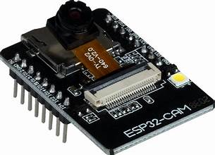
Photo with camera after applying the code :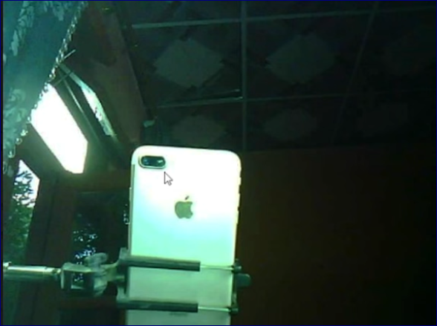

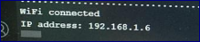
The IP address can be entered in any browser to view the images, which are updated at regular intervals you decided on code .

The code with server :
#include "esp_camera.h"
#include <WiFi.h>
#include <HTTPClient.h>

// ===== WIFI =====
const char* ssid = "AHMED";
const char* password = "KLM1375H";

// ===== NGROK UPLOAD URL =====
// MUST end with /upload
const char* uploadUrl = "https://true-crabs-march.loca.lt/upload";

// ===== CAMERA PINS (ESP32 WROVER KIT) =====
#define PWDN_GPIO_NUM -1
#define RESET_GPIO_NUM -1
#define XCLK_GPIO_NUM 21
#define SIOD_GPIO_NUM 26
#define SIOC_GPIO_NUM 27

#define Y9_GPIO_NUM 35
#define Y8_GPIO_NUM 34
#define Y7_GPIO_NUM 39
#define Y6_GPIO_NUM 36
#define Y5_GPIO_NUM 19
#define Y4_GPIO_NUM 18
#define Y3_GPIO_NUM 5
#define Y2_GPIO_NUM 4
#define VSYNC_GPIO_NUM 25
#define HREF_GPIO_NUM 23
#define PCLK_GPIO_NUM 22

void setup() {
Serial.begin(115200);
Serial.println("Booting...");

// ===== CAMERA CONFIG =====
camera_config_t config;
config.ledc_channel = LEDC_CHANNEL_0;
config.ledc_timer = LEDC_TIMER_0;
config.pin_d0 = Y2_GPIO_NUM;
config.pin_d1 = Y3_GPIO_NUM;
config.pin_d2 = Y4_GPIO_NUM;
config.pin_d3 = Y5_GPIO_NUM;
config.pin_d4 = Y6_GPIO_NUM;
config.pin_d5 = Y7_GPIO_NUM;
config.pin_d6 = Y8_GPIO_NUM;
config.pin_d7 = Y9_GPIO_NUM;
config.pin_xclk = XCLK_GPIO_NUM;
config.pin_pclk = PCLK_GPIO_NUM;
config.pin_vsync = VSYNC_GPIO_NUM;
config.pin_href = HREF_GPIO_NUM;
config.pin_sscb_sda = SIOD_GPIO_NUM;
config.pin_sscb_scl = SIOC_GPIO_NUM;
config.pin_pwdn = PWDN_GPIO_NUM;
config.pin_reset = RESET_GPIO_NUM;
config.xclk_freq_hz = 20000000;
config.pixel_format = PIXFORMAT_JPEG;

config.frame_size = FRAMESIZE_QVGA;
config.jpeg_quality = 12;
config.fb_count = 1;

if (esp_camera_init(&config) != ESP_OK) {
Serial.println("❌ Camera init failed!");
return;
}
Serial.println("📷 Camera started.");

// ===== WIFI =====
WiFi.begin(ssid, password);
Serial.print("Connecting to WiFi");
while (WiFi.status() != WL_CONNECTED) {
Serial.print(".");
delay(400);
}
Serial.println("\n✔ WiFi connected");
}

void loop() {

Serial.println("📸 Capturing image...");
camera_fb_t *fb = esp_camera_fb_get();

if (!fb) {
Serial.println("❌ Capture failed");
delay(2000);
return;
}

Serial.printf("Image size: %d bytes\n", fb->len);

// ===== BYPASS SSL HANDSHAKE =====
WiFiClientSecure client;
client.setInsecure(); // <<< THIS BYPASSES CERTIFICATE VALIDATION

HTTPClient http;
http.begin(client, uploadUrl);

// =========================================================
// === AUTHENTICATION HEADER ADDED HERE ====================
// =========================================================
// Base64-encoded value for credentials: :156.202.45.89
const char* authHeaderValue = "Basic OjE1Ni4yMDIuNDUuODk=";
http.addHeader("Authorization", authHeaderValue);
// =========================================================

http.addHeader("Content-Type", "image/jpeg");

// Send POST request
int response = http.POST(fb->buf, fb->len);

Serial.print("Server Response: ");
Serial.println(response);

if (response > 0) {
Serial.println(http.getString());
} else {
Serial.println("❌ Failed to send POST");
}

http.end();
esp_camera_fb_return(fb);

delay(5000); // wait 5 seconds before next photo
}

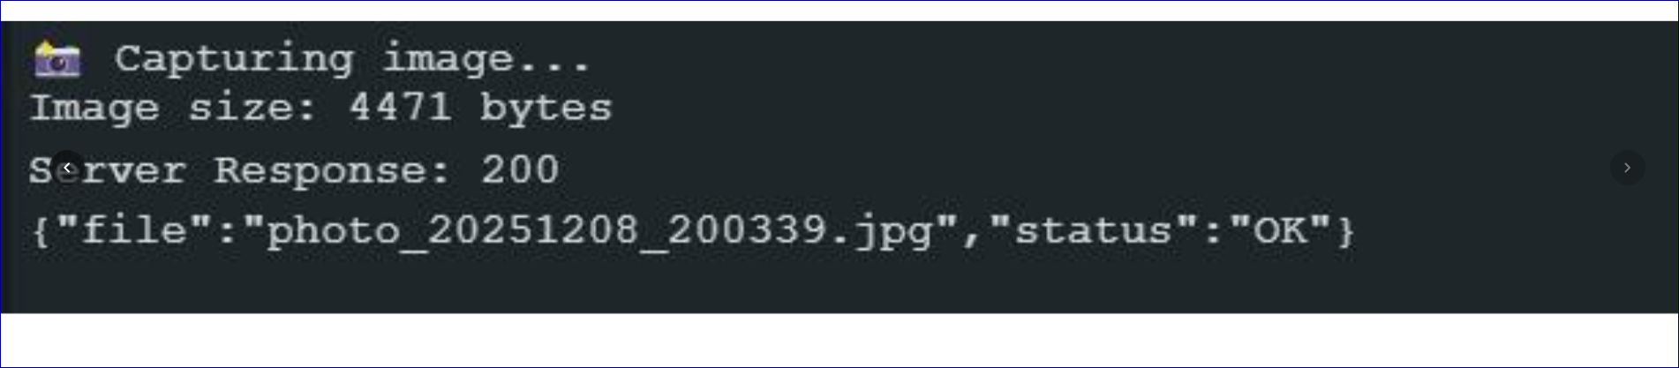
This indicate that the photo that had captured send to server by the Tunnel URL on the code .
From the server other point of view .
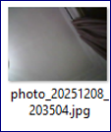

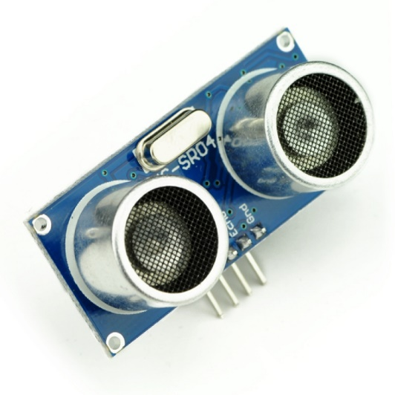
#define TRIG_PIN D5 // GPIO14
#define ECHO_PIN D6 // GPIO12

void setup() {
Serial.begin(115200);
pinMode(TRIG_PIN, OUTPUT);
pinMode(ECHO_PIN, INPUT);
}

void loop() {
long duration;
float distance_cm;

// Send a 10µs pulse to trigger
digitalWrite(TRIG_PIN, LOW);
delayMicroseconds(2);
digitalWrite(TRIG_PIN, HIGH);
delayMicroseconds(10);
digitalWrite(TRIG_PIN, LOW);

// Read the echo pulse duration
duration = pulseIn(ECHO_PIN, HIGH);

// Calculate distance in cm
distance_cm = (duration * 0.0343) / 2;

Serial.print("Distance: ");
Serial.print(distance_cm);
Serial.println(" cm");

delay(500);
}

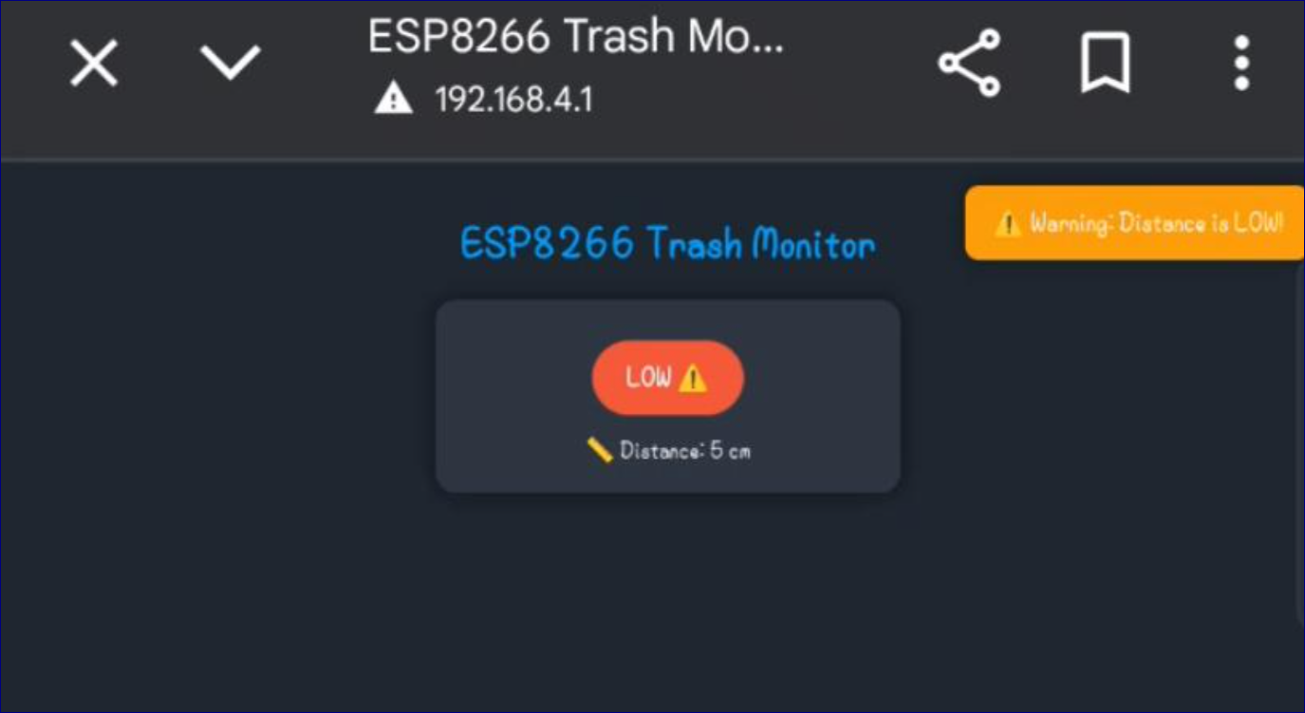
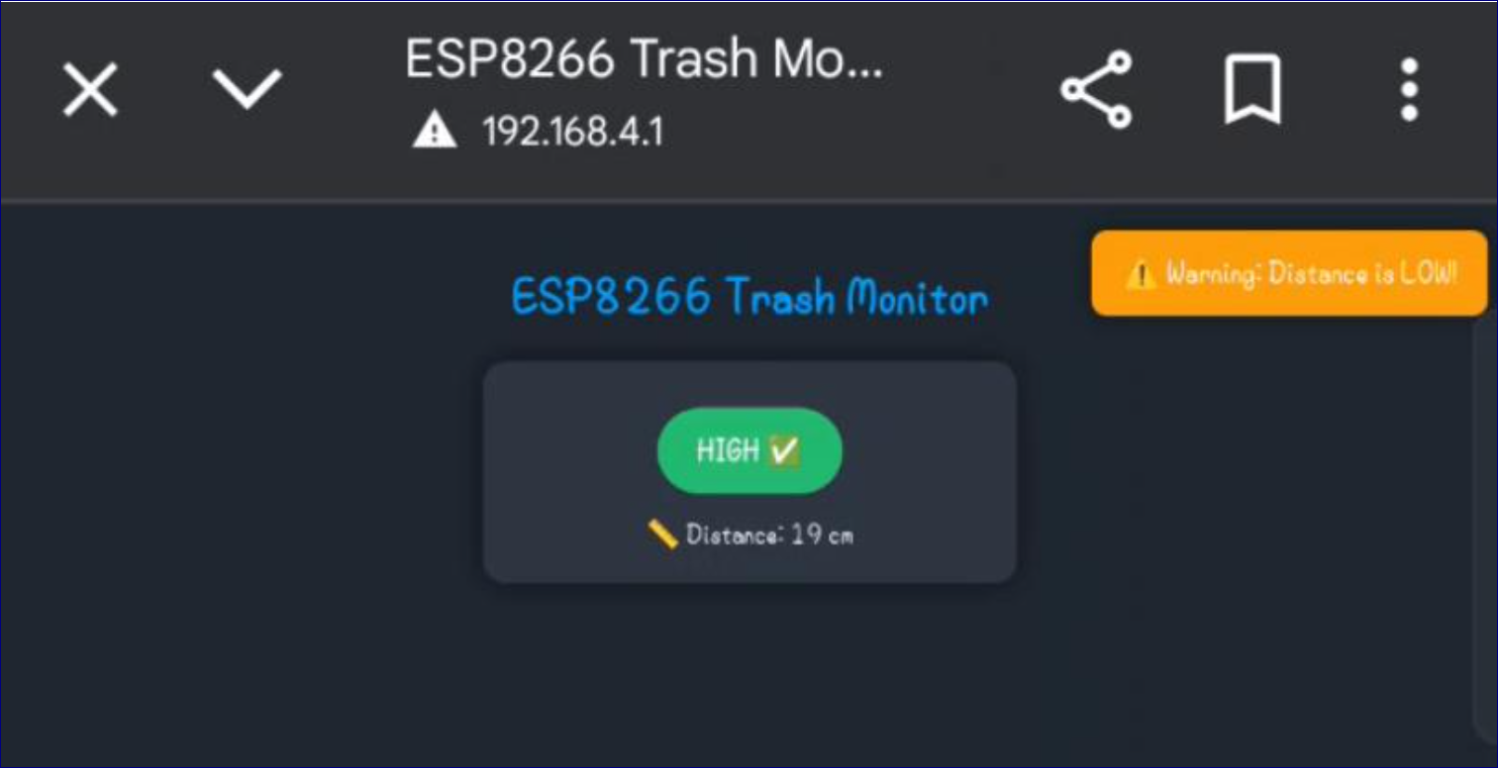

The GPS NEO-6M GPS Module with EPROM

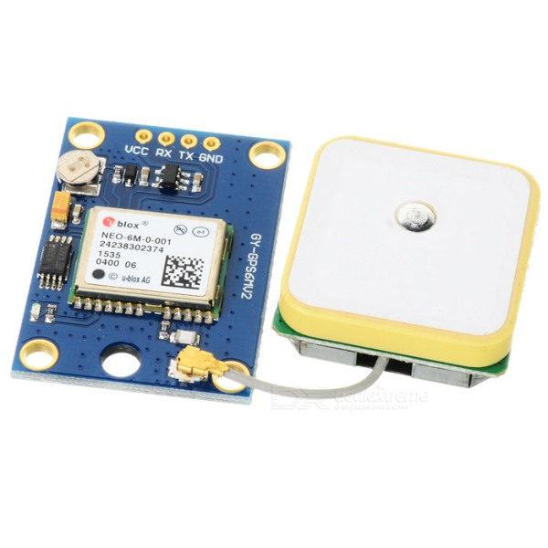
#include <SoftwareSerial.h>
#include <TinyGPSPlus.h>
#include <ESP8266WiFi.h>

// ------------------
// GPS Setup
// ------------------
const int RXPin = 4; // D2
const int TXPin = 5; // D1
SoftwareSerial neo6m(RXPin, TXPin);
TinyGPSPlus gps;

// ------------------
// WiFi Setup
// ------------------
const char* ssid = "AHMED";
const char* password = "KLM1375H";
WiFiServer server(80);

// ------------------
// Last known location
// ------------------
double lastLat = 0.0;
double lastLng = 0.0;

void setup() {
Serial.begin(115200);
delay(100);
neo6m.begin(9600);

// Connect to WiFi
Serial.print("Connecting to WiFi: ");
Serial.println(ssid);
WiFi.begin(ssid, password);
int retries = 0;
while (WiFi.status() != WL_CONNECTED) {
delay(500);
Serial.print(".");
retries++;
if (retries > 30) {
Serial.println("\nFailed to connect. Restarting...");
ESP.restart();
}
}
Serial.println("\nWiFi connected!");
Serial.print("IP Address: ");
Serial.println(WiFi.localIP());

server.begin();
}

void loop() {
// Read GPS data
while (neo6m.available()) {
gps.encode(neo6m.read());
}

// Update last known coordinates if GPS fix available
if (gps.location.isValid()) {
lastLat = gps.location.lat();
lastLng = gps.location.lng();
Serial.print("Latitude: "); Serial.println(lastLat, 6);
Serial.print("Longitude: "); Serial.println(lastLng, 6);
}

// Handle web client
WiFiClient client = server.available();
if (client) {
Serial.println("New client connected");
String currentLine = "";

while (client.connected()) {
if (client.available()) {
char c = client.read();
if (c == '\n') {
if (currentLine.length() == 0) {
// Build HTML
String html = "<!DOCTYPE html><html><head>";
html += "<meta charset='UTF-8'><meta name='viewport' content='width=device-width, initial-scale=1.0'>";
html += "<title>ESP8266 GPS Tracker</title></head><body>";
html += "<h1>ESP8266 GPS Tracker</h1>";

if (gps.location.isValid()) {
html += "<p>Latitude: " + String(lastLat,6) + "</p>";
html += "<p>Longitude: " + String(lastLng,6) + "</p>";
html += "<p>GPS Fix Acquired!</p>";
} else {
html += "<p>Searching for satellites...</p>";
}

html += "</body></html>";
client.print(html);
break;
} else {
currentLine = "";
}
} else if (c != '\r') {
currentLine += c;
}
}
yield();
}
client.stop();
Serial.println("Client disconnected");
}
}
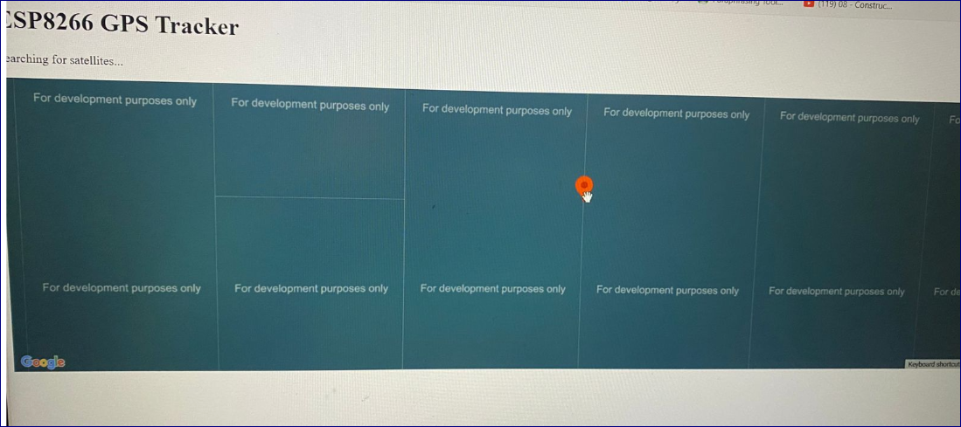
The component that we should buy

4* Ultrasonic sensors for the classification portions 80*4LE 320LE
Another ESP 400 LE
Another Servo motor more stronger
Nema 17 Stepper Motor 17HS6401 60mm High-Torque 2-Phase Hybrid Stepper Motor (1) 940 LE

